Technical Architecture:

Project Design Phase-II Technology Stack (Architecture & Stack)

|  |  |
| --- | --- |
| Date | 07 November 2022 |
| Team ID | PNT2022TMID07637 |
| Project Name | Project - AI based localization and classification  of skin disease with erythema |
| Maximum Marks | 4 Marks |

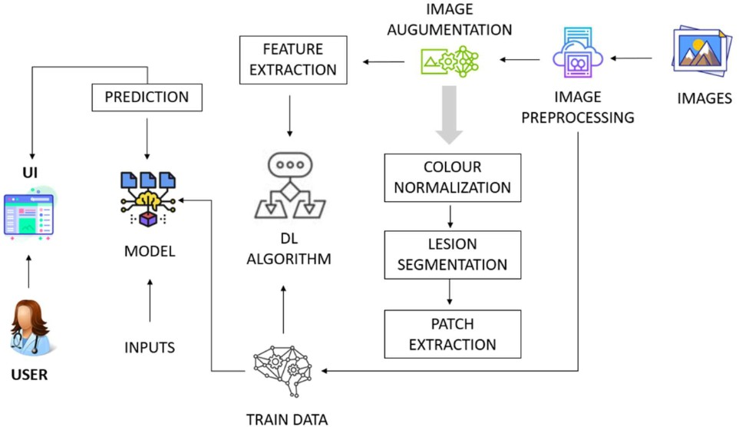

Table-1 : Components & Technologies:

|  |  |  |  |
| --- | --- | --- | --- |
| **S.No** | **Component** | **Description** | **Technology** |
| 1. | User Interface | Website is built using HTML and CSS. Javascript to make the webpage interactive for  users. | HTML, CSS, JavaScript . |
| 2. | Application Logic-1 | A page to upload images as input and pre-process it. | Python |
| 3. | Application Logic-2 | To use the Machine Learning model and predict the result | IBM Watson studio |
| 4. | Database | To store user inputs and previous results and retrieve information | MySQL |
| 5. | Cloud Database | Database that typically runs on a cloud computing  platform and access to the database is provided as a service | IBM Cloudant. |
| 6. | File Storage | File storage requirements | Local Filesystem |
| 7. | External API | To fetch storage requirements | REST API |
| 8. | Machine Learning Model | To build a ML model using CNN and train it to  detect patterns in the inputs | Deep learning using Python and YOLO  model |

Table-2: Application Characteristics:

|  |  |  |  |
| --- | --- | --- | --- |
| **S.No** | **Characteristics** | **Description** | **Technology** |
| 1. | Open-Source Frameworks | To automate various functions and processes in web application and maintain efficiency in interface development | Python-Flask |
| 2. | Security Implementations | In all aspects of the job,including detecting  malicious attacks,analyzing the network,endpoint protection and vulnerability assessment,sign in encryption. | IBM cloud app ID services |
| 3. | Scalable Architecture | Application is scalable to support higher workload  as no.of users increases over time,Modular design used to achieve reliable scalability. | nodeJS |
| 4. | Availability | Use of load balancers,distributed servers | nginx |
| 5. | Performance | To enable fast loading of library files on our webpage and display the result in the shortest time possible while being error free. | cdnjs,Angular JS |